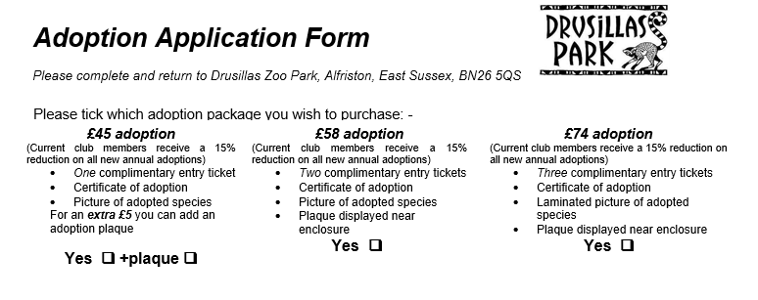

Please enter the details of the animal you would like to adopt
Animal Species & Name (from “animals available for adoption list”)
Is this a renewal Yes or No | Is this a transfer Yes or No | Are you a Club Member Yes or No  (current club members receive a 15% reduction on all new annual adoptions)
Do you wish to add a £2 donation towards Drusillas Charity of the Year – Yes or No

Feepayer details

Title, forename & surname
Organisation name (if applicable)
Your position in organisation (if applicable)
Address including Postcode
Daytime telephone number
We will contact you by telephone for credit card details to process the payment
E-mail
Drusillas Zoo Park Ltd would like to send you information about our half price entry offers and our other marketing activities. If you would like to receive this information please tick this box

Unless a date is specified below the adoption will commence on the date we receive your application. We will contact you or the recipient towards the end of the adoption to see if you wish to renew your support for a further year. It may also be necessary to contact you or your recipient, in accordance with your instructions below, due to any unexpected change of circumstances regarding the adopted animal (this could include a letter if your chosen animal has to be re-homed or unfortunately dies).
Please complete these sections if the adoption is a gift

Specific start date (i.e. birthday or Christmas)
Please send the adoption pack to You or Recipient
Please send the renewal reminder to You or Recipient
Please send any correspondence to You or Recipient

Adoption Recipient details

Title, forename & surname
Address including Postcode
Daytime telephone number
Date of birth if under 18

