Amazing Animals – Giant anteaters

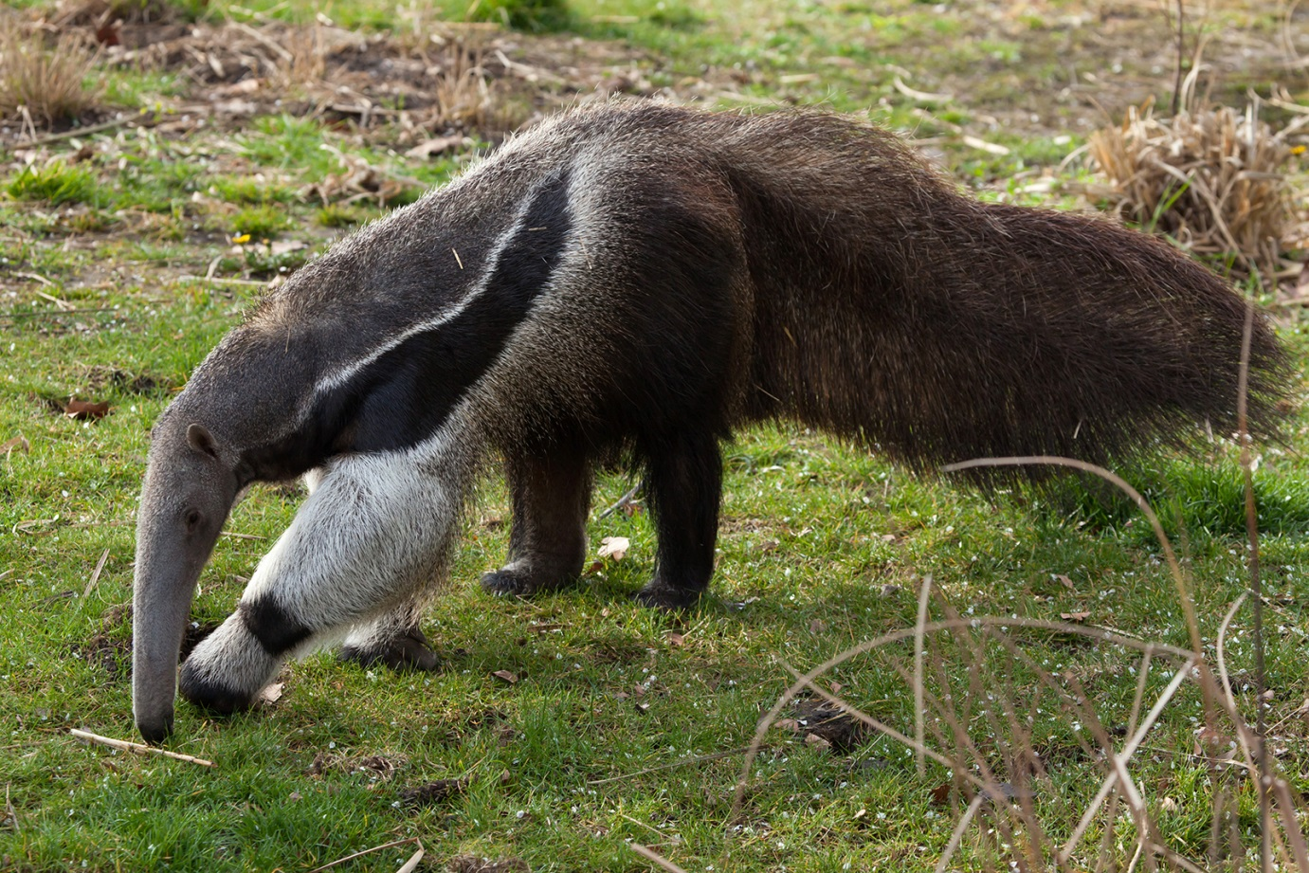

Where are anteaters found in the wild? Grasslands and tropical forests in Central and South America.
How many ants and termites can they eat in a day? Up to 30,000
What are they fed at Drusillas? Termant (a specially made mixture used by zoos that contains protein, fibre, vitamins and minerals)
Name three adaptations that help anteaters survive.
1) Strong claws to break into termite mounds
2) Long sticky tongue to pick up ants
3) Thick fur to keep themselves warm (grasslands can get cold)
Amazing Animals – Two-toed sloths

.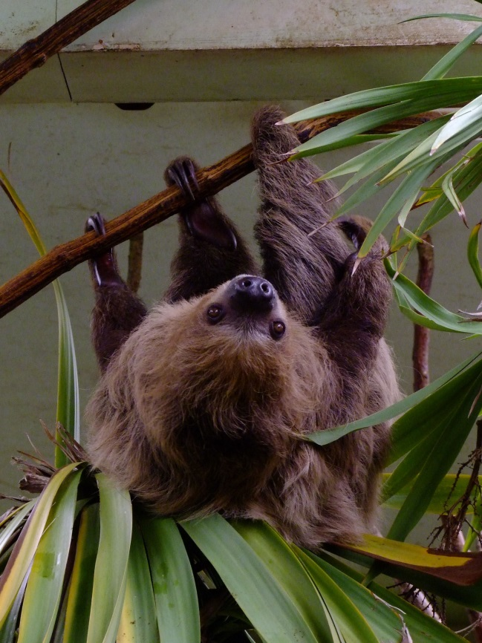

What is a sloth’s habitat? Sloths are found in tropical forests in Central and South America. Linne’s two-toed sloths are found in tropical rainforests in northern South America.
Why are some sloths green in the wild? Algae (tiny plants) grow on them.
What do they only do once a week? They only urinate and defecate (wee and poo) about once a week.
Why are they slow? They feed mostly on leaves which take a long time to digest and don’t provide much energy.

Amazing Animals – Binturongs

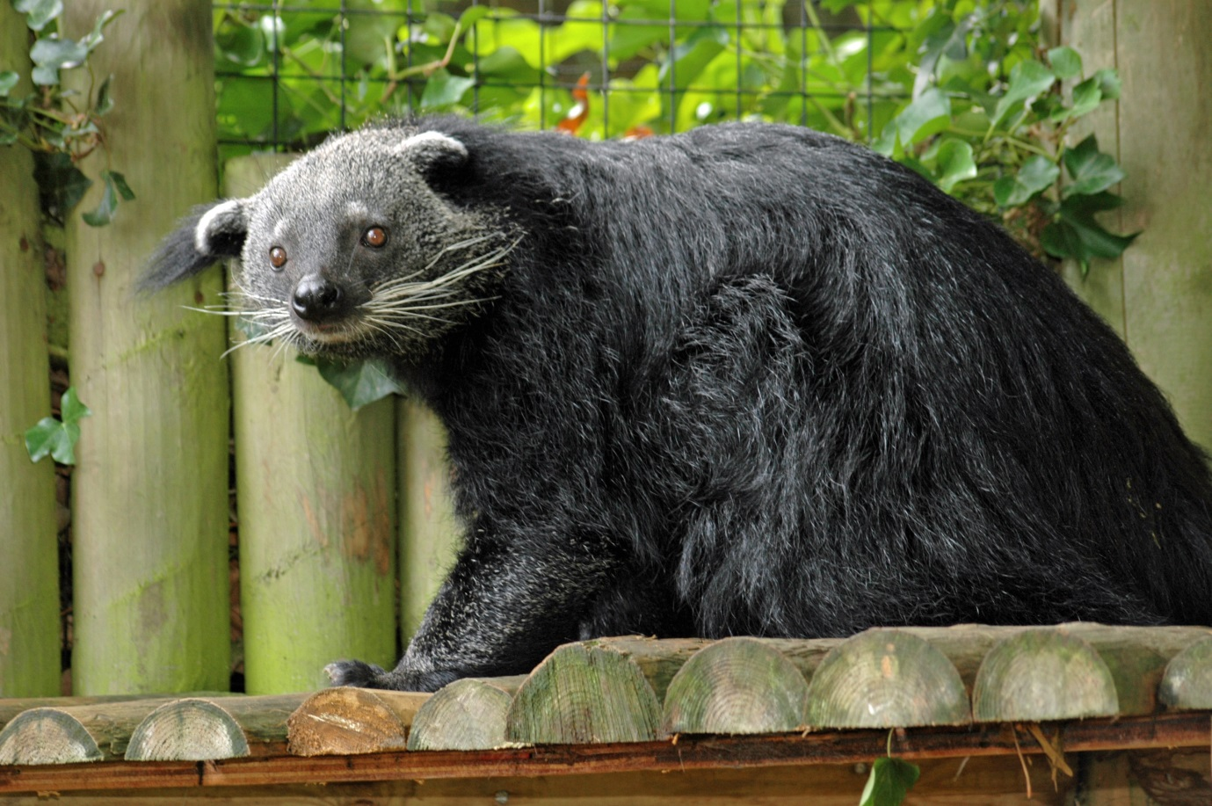

What are binturongs also called? Bear cats.
Where in the world are they found? Tropical forests in south-east Asia.
What do they smell like? Buttered popcorn!
What is a prehensile tail? Can hold onto things and used like an extra arm.
What can they do with their ankles? They can turn their ankles backwards so that they can still grip when walking down trees headfirst.

Amazing Animals
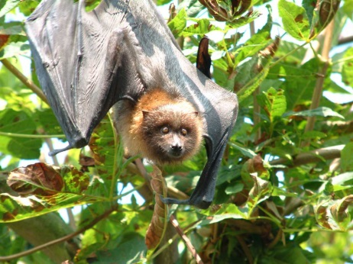
What bones are in a bats wing?
Fingers (their wing is equivalent to a hand).
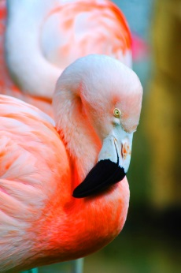
Why are flamingos pink?
From the food (small shrimps they eat).
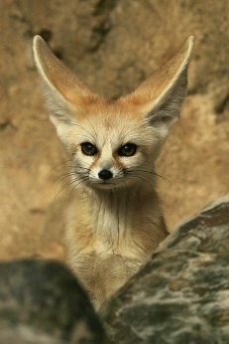
Why do fennec foxes have big ears?
To hear prey such as insects walking on sand.
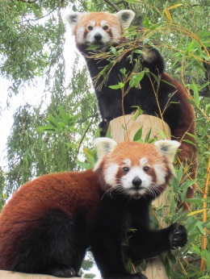
How high can red pandas live?
Up to 5,000 metres.
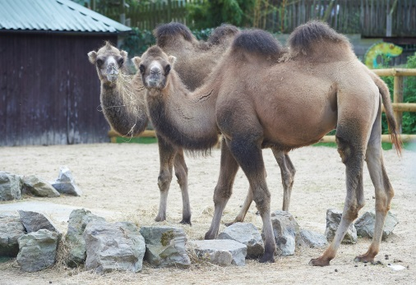
What is in a camels’ hump?
Lumps of fat (they can go for up to three weeks without eating).

