Amazing Animals – Giant anteaters

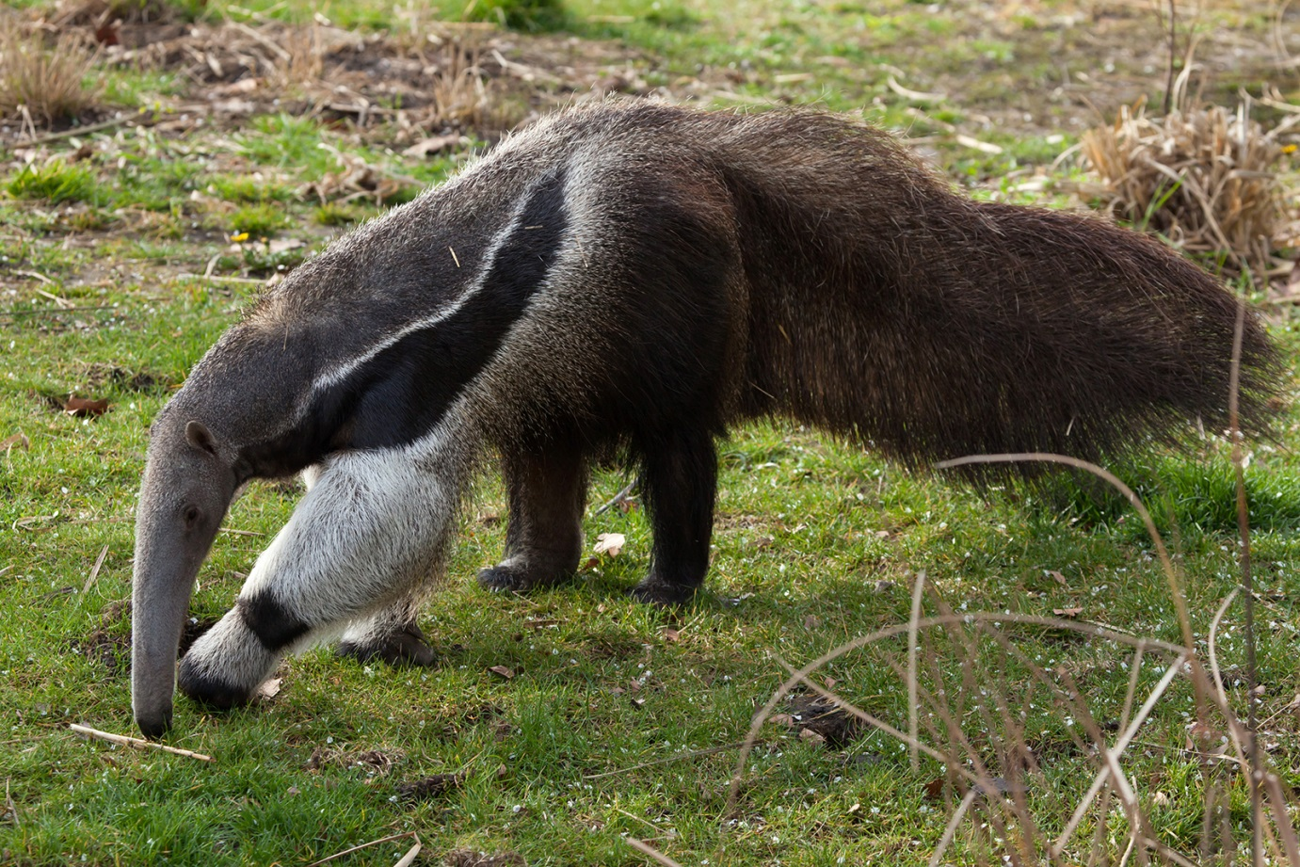

Where are anteaters found in the wild?

How many ants and termites can they eat in a day?

What are they fed at Drusillas?

Name three adaptations that help anteaters survive.
1)
2)
3)
Amazing Animals – Two-toed sloths

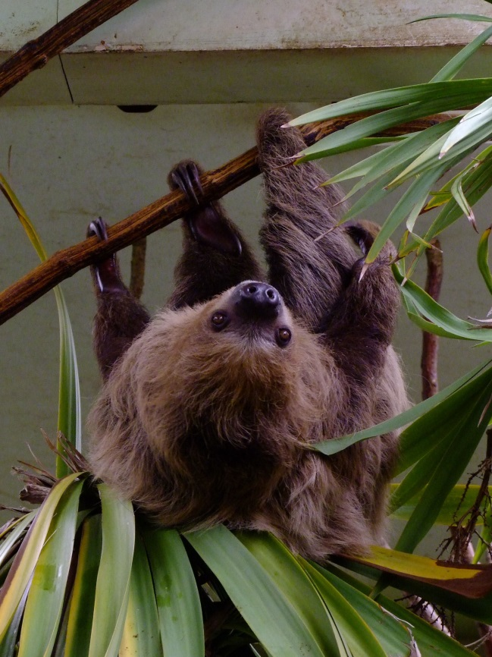

What is a sloth’s habitat?

Why are some sloths green in the wild?

What do they only do once a week?

Why are they slow?

Amazing Animals – Binturongs

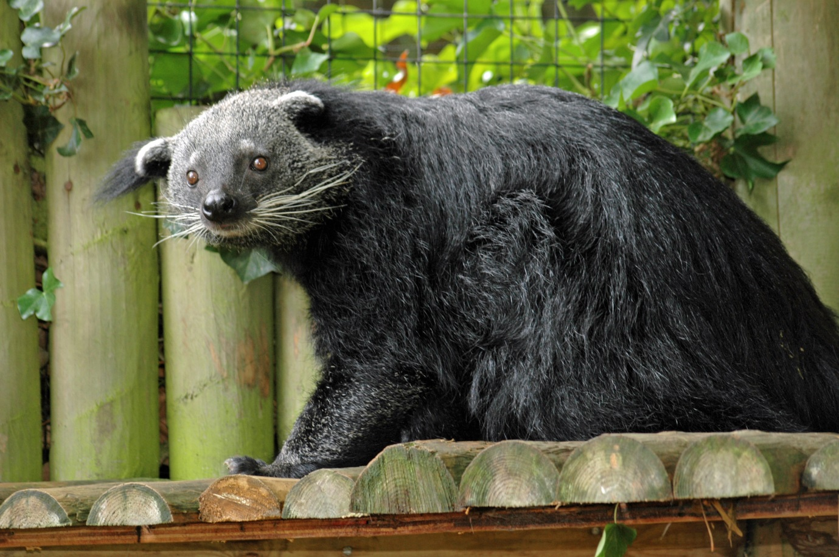

What are binturongs also called?

Where in the world are they found?

What do they smell like?

What is a prehensile tail?

What can they do with their ankles?
Amazing Animals
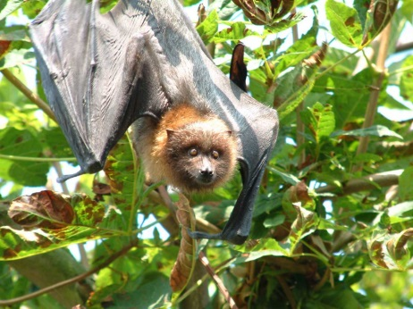
What bones are in a bats wing?
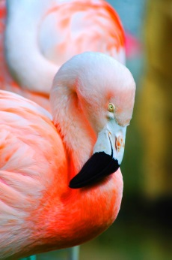
Why are flamingos pink?
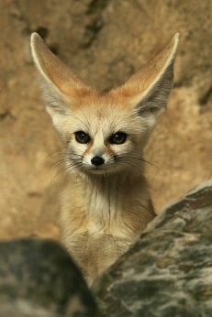
Why do fennec foxes have big ears?
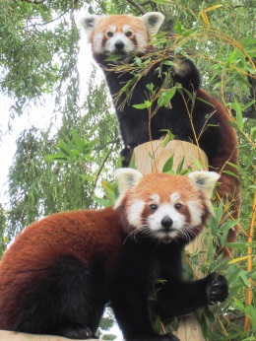
How high can red pandas live?
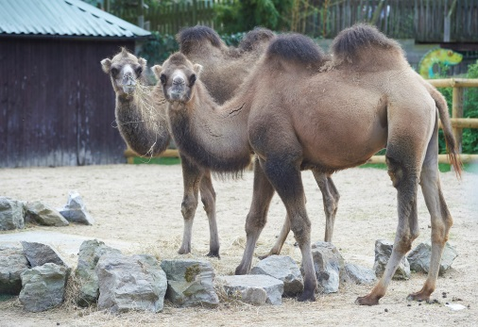
What is in a camels hump?

