**Drusillas most dangerous animals**

**Many of these animals can give a nasty bite but some have other defences!**

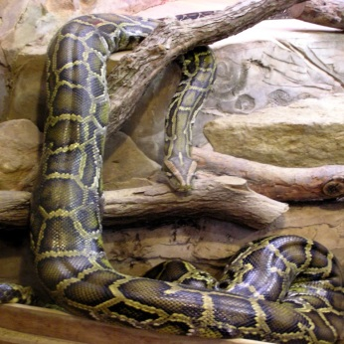

**Burmese python**

How do they kill their prey?

Constriction (squeezing) Biting Spitting

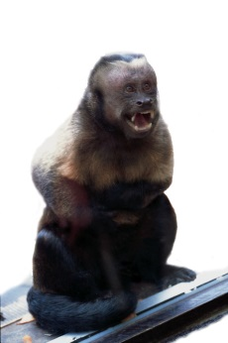

**Capuchin monkey**

What is special about their tail?

Comes off Finds prey Prehensile (can hold onto things)

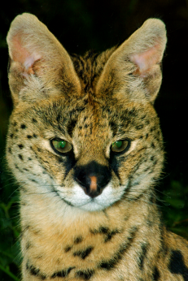

**Serval**

How high can they jump?

1 metre 2 metres 3 metres 5 metres

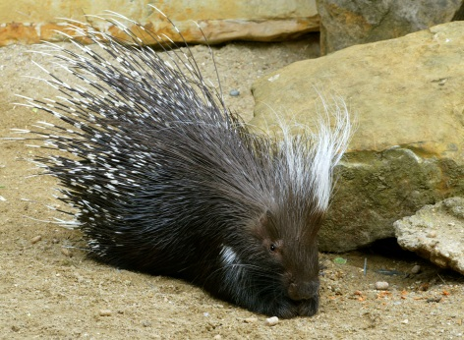

**Porcupine**

What do they do with their quills?

Shoot them Charge backwards Cover themselves

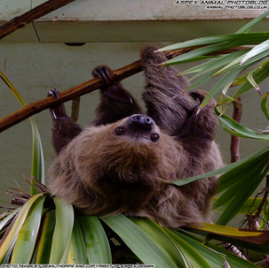

**Two-toed sloth**

What is the most dangerous?

Teeth (overall) Claws (can also be dangerous) Fur Wee

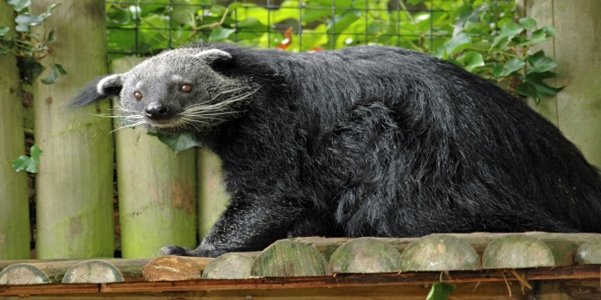

**Binturong**

What are they known as?

Shaggy dogs Forest anteaters Bear cats

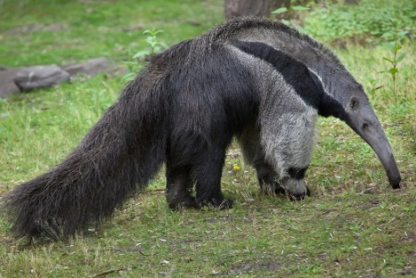

**Giant anteater**

How do they get termites to eat?

Tail Nose Tongue Claws

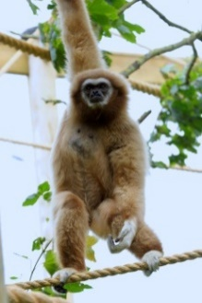

**Lar gibbon**

Why are they so strong?

Opening nuts Swinging through trees Eating beetles

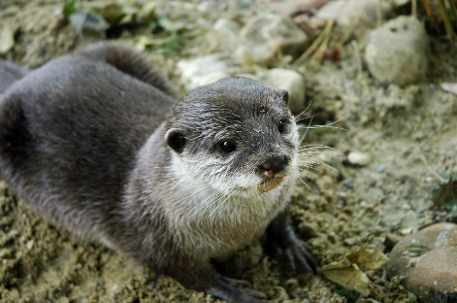

**Asian short-clawed otter**

What do they like to eat?

Fish Crabs Mice Sparrows

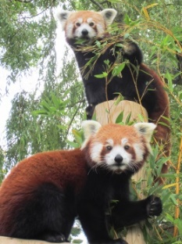

**Red panda**

What do people think they might be related to?

Pandas Foxes Racoons Badgers