**Drusillas most dangerous animals**

**Many of these animals can give a nasty bite but some have other defences!**

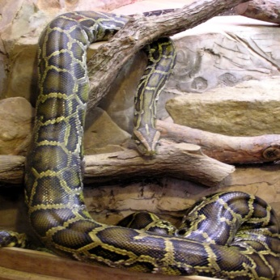

**Burmese python**

How do they kill their prey?

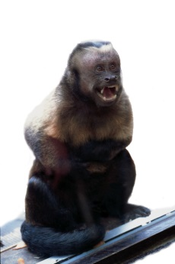

**Capuchin monkey**

What is special about their tail?

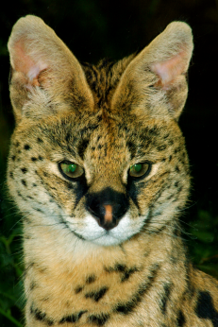

**Serval**

How high can they jump?

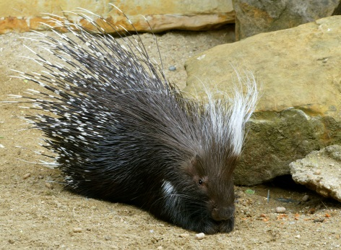

**Porcupine**

What do they do with their quills?

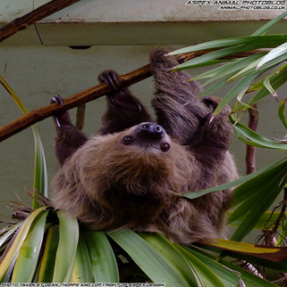

**Two-toed sloth**

What is the most dangerous?

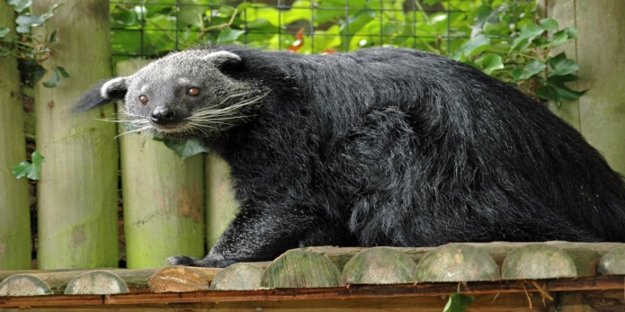

**Binturong**

What are they known as?

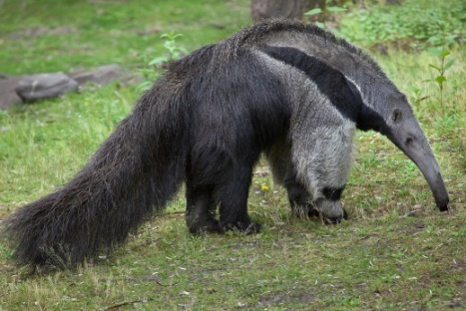

**Giant anteater**

How do they get termites to eat?

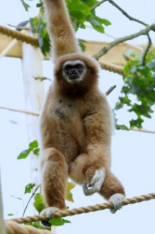

**Lar gibbon**

Why are they so strong?

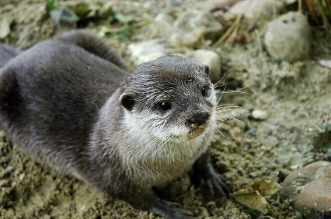

**Asian short-clawed otter**

What do they like to eat?

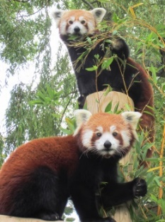

**Red panda**

What do people think they might be related to?