**Drusillas most dangerous animals**

**Many of these animals can give a nasty bite but some have other defences!**

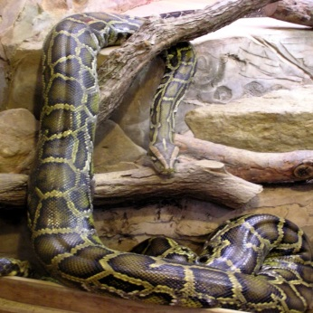

**Burmese python**

How do they kill their prey? They are constrictors / squeeze their prey. The prey animal usually dies due to its heart stopping.

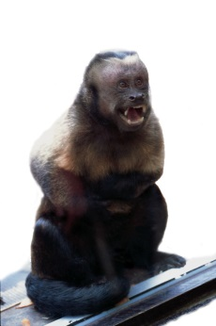

**Capuchin monkey**

What is special about their tail? It is prehensile / can be used like an extra arm / limb.

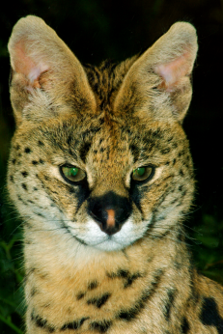

**Serval**

How high can they jump? Up to 3 metres.

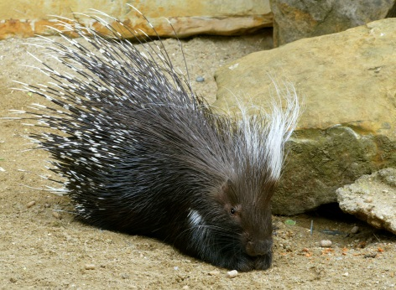

**Porcupine**

What do they do with their quills? Charge backwards into animals that threaten them. Quills may be left in the other animal and can cause infections.

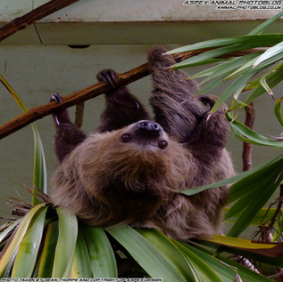

**Two-toed sloth**

What is the most dangerous part of their body? Long claws can be dangerous, but teeth can give a very nasty bite. Teeth can be worse!

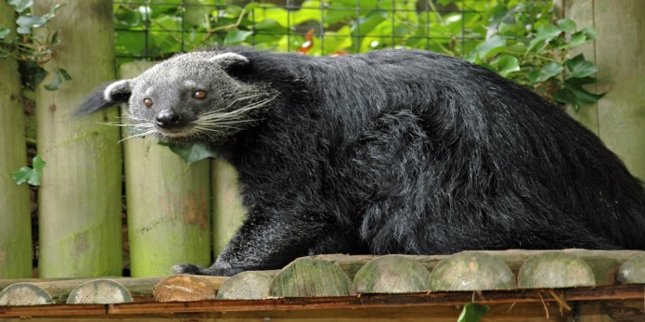

**Binturong**

What are they known as? Bear cats

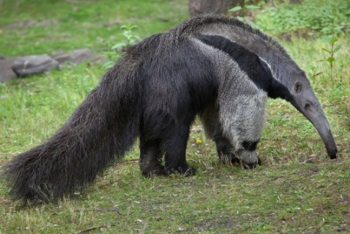

**Giant anteater**

How do they get termites to eat? Rip open termite mounds with claws, pick them up on sticky tongue and suck them up nose.

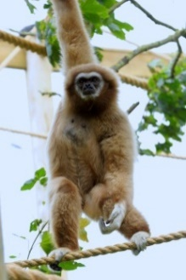

**Lar gibbon**

Why are they so strong? So they can swing quickly through trees.

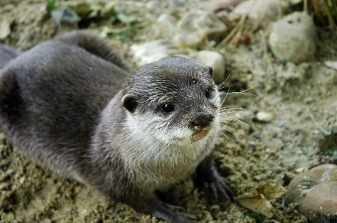

**Asian short-clawed otter**

What do they like to eat? Crab claws area favourite, they also eat shellfish, frogs and fish.

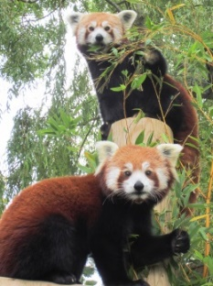

**Red panda**

What do people think they might be related to? Racoons