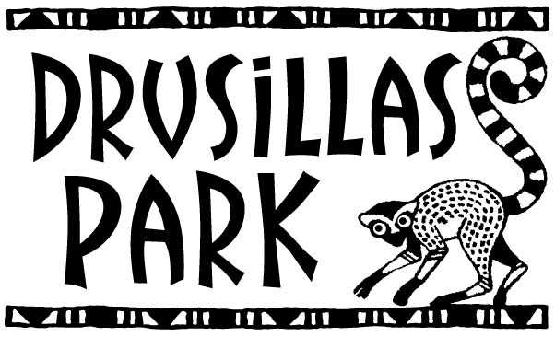

January Sale!
Terms and Conditions
The offer will be valid from Saturday 6th January to Sunday 28th January inclusive.
The offer will allow one individual entry to Drusillas for 50% off the “at the gate” entry price
Each person entering the Park for 50% must be accompanied by either a current Annual Member visiting on the day, or by one full paying adult visiting on the day.
One full paying adult or annual member for each 50% entry is required.
A full paying adult is an adult paying the full individual entry price at the gate on the day of entry and does not include online tickets.
There is no flexibility to change to any other dates.
The offer cannot be used in conjunction with any other offers including Tesco Vouchers, online tickets or any other free or discounted entry tickets.
You must print the voucher below and hand it in at the gate upon arrival.
**Please note: Drusillas is not able to print this voucher for you. In order to obtain the offer you must print and complete the voucher below before arriving at the gate. Mobile copies or copies on electronic devices cannot be accepted.
-------------------------------------------------------------------------------------------------------------------------------------------------------------

