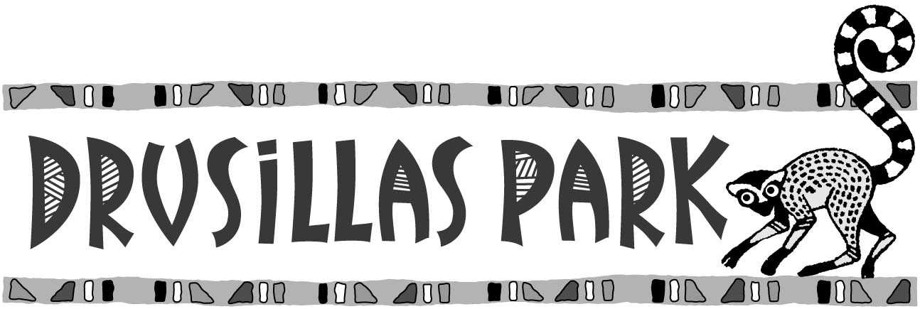

Sizzling Summer Offer! Kids go for £5 this weekend!

Britain is bracing for an almighty heatwave! We are celebrating the sunshine with an AMAZING OFFER!
This weekend, Saturday 21st July and Sunday 22nd July 2018, children can come to Drusillas for just £5! Each child entering for £5 must be accompanied by a full paying individual or a current annual member visiting with them on the day.
There are just a few terms relating to the offer and they are listed below:

Terms and Conditions
- This offer is only valid on Saturday 21st July and Sunday 22nd July 2018.
- This offer admits one child for £5 when accompanied by a current annual member or an adult paying the full individual entrance price at the gate on the day.
- Each child entering the Park for £5 MUST be accompanied by either a full paying individual or a current adult or child annual member.
- There is no flexibility to change to any other dates.
- This offer cannot be used in conjunction with any other offers including Tesco Vouchers, online tickets or any other free or discounted entry tickets.
- To obtain the discount, please bring a paper copy of this voucher with you on arrival. If you are unable to print this voucher, we will accept copies shown on mobile devices.

