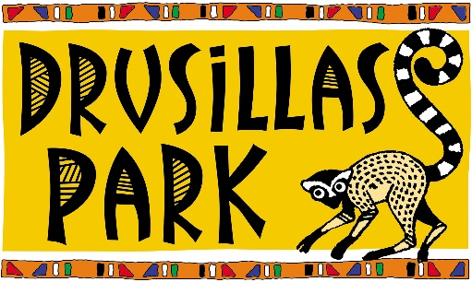
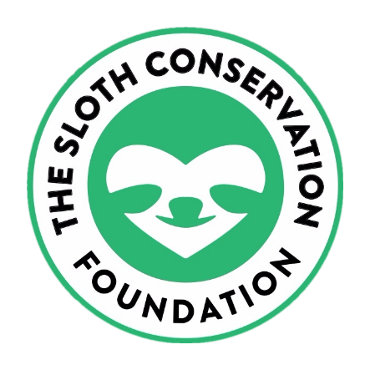

About SLoCo
Sloth populations are in decline throughout South and Central America as they struggle to adapt to the urbanisation of the rainforest. Saving the world’s slowest mammal from extinction now requires innovative and long-term conservation solutions that target both human and sloth populations. The Sloth Conservation Foundation is a registered non-profit organisation that aims to protect sloths in the wild through research and conservation initiatives. They have developed a range of community-based strategies and programs that provide sustainable ways in which humans and sloths can coexist peacefully.
The Sloth Conservation Foundation is a UK registered charity based in Costa Rica. SloCo primarily work in the South Caribbean region, which is an area characterised by high poverty, low levels of education and a very rapid rate of development compared to the rest of the country.
This region is widely considered to be the best place in the world to see sloths in the wild, but this is unfortunately a bad sign for the health of the ecosystem. In a healthy rainforest, you will struggle to see any sloths. They will be hidden high-up in the canopy – where they should be.
In the South Caribbean sloths are quite literally falling out of the trees. They are crawling across roads, through gardens, climbing on electricity lines and trying to survive in increasingly urbanised areas. SloCo’s work is prioritised in this region to establish sustainable ways for humans and sloths to co-exist, and then these projects will be expanded to other regions. SloCo also fund sloth conservation projects in Panama with the critically endangered pygmy sloth, and in Brazil with the vulnerable maned sloth.
What does SloCo do with donated money? How does my donation help?
All funds raised go directly towards running SloCo’s 7 primary conservation programs that help to protect sloths in the wild. These include:
- Insulating power lines
Sloths climb on the electricity lines to travel between trees in urban areas, and the cables are very poorly insulated. There are more than 3000 wildlife electrocutions every single year in Costa Rica and over half of the electrocuted animals are sloths. The survival rate following an electrocution is only about 25%. SloCo fund the raw materials needed to insulate power lines in Costa Rica and we work with the electricity company to install the insulations.
- Saving sloths by sterilising dogs
Domestic and stray dog attacks are now the second leading cause of death for sloths in Costa Rica. Rapid development of the rainforest means that the connectivity between neighbouring trees is being lost and the sloths are forced to travel around on the ground. A sloth on the ground has no defence against a dog! SloCo spay and neuter stray dogs in Costa Rica with the aim of reducing the overall number of uncontrolled dogs roaming freely that might attack sloths. We also teach responsible pet ownership skills to local communities.
- Bridging the gap
Without a natural or artificial canopy bridge, the only way for a sloth to cross a road is by crawling on the ground. This takes a lot of time and energy and they often get hit by cars when the driver does not see the sloth in the road. SloCo build and install specialized ‘sloth crossing’ canopy bridges to connect forest fragments in disturbed areas. These bridges give sloths and other wildlife a safe way to travel across roads and through urban areas without having to risk traveling on the ground.

- Educating the next generation
SloCo work with local children through their education outreach programs to encourage the protection rather than the exploitation of wildlife. During each workshop the children are taught about the biology of sloths, the importance of the ecosystem, the challenges that sloths are facing and how they can help.
- Responsible tourism campaigns
Sloths are not poached for food or body parts, but they are poached to feed the ever-growing demand for hands-on wildlife encounters. Baby sloths are ripped away from mom in the wild and are exploited as tourist attractions until they die – and then they are replaced. Sloths are now the number 1 victims of the global “wildlife selfie trade”. SloCo are promoting responsible “sloth tourism” in high tourist areas throughout Costa Rica by establishing permanent signage and providing information materials in local businesses and hotels. SloCo also coordinate international online campaigns to raise awareness of the ‘wildlife selfie’ and illegal pet trade markets.
- Habitat restoration and protection
Sloths in Costa Rica are frequently being born with genetic abnormalities. These include missing fingers/toes, malformed ears, misshapen limbs and partial or full albinism. High numbers of birth defects like this in any population are a warning sign that something is seriously wrong. SloCo’s research has shown that this is likely due to inbreeding from habitat loss. We are restoring and protecting critical sloth habitats through reforestation (with tree species favoured by sloths) and the creation of biological corridors and protected forest reserves. The trees are grown in our forest nursery and SloCo work with the local community to plant the saplings in key areas. SloCo provide training and signage to ensure that the community know how to care for the trees and ensure their survival.
- Research
In order to develop and implement any good conservation strategy, a solid scientific knowledge of the sloth’s ecological requirements is necessary. For this reason, SLOCO fund, coordinate and publish high quality research into many different aspects of sloth biology and ecology. SLOCO’s current research efforts focus on: sloth behaviour and how this is influenced by the environment, the population genetics of sloths in Costa Rica and the survival of hand-reared orphan sloths post-release.

How can I get involved or help from home?
One person at a time, one day at a time, and one project at a time, we all have the ability to make a serious difference that will leave a lasting impact on the world. Don’t ever underestimate the power that you have in your day-to-day actions!
- Volunteer
If you love sloths, would like to help SloCo in our mission, have specific skills which you think may be beneficial, and are up for a challenge then they may have a position for you! Email SloCo to discover our current volunteer opportunities!
- Donate
As a non-profit organisation, SloCo rely on your kind support to make our work possible. There are many different ways to support SloCo: you can adopt a sloth, sponsor a ‘Sloth Crossing’, fund a particular project, browse our online shop or surprise us with something from our Wish List!

- Fundraise for SLOCO
You can use one of SloCo’s online platforms to host your very own sloth fundraiser! Just visit their website for details. Or help Drusillas by donating via their just giving page.

- Offset your carbon footprint
By planting trees through our tropical habitat restoration program in Costa Rica, you can provide safe habitat for sloths and other wildlife, protect biodiversity and help to reduce the amount of carbon dioxide in the atmosphere. It’s a triple win! If you have travel plans, you can use SloCo’s free online calculator to work out how many rainforest trees you need to plant to offset the ecological carbon footprint of your travels! SloCo will choose tree species that are favoured by wild sloths and they will plant them in your name in key conservation areas where habitat loss is threatening the survival of sloths.

- Make a personal difference every day:

- Choose your food carefully – The production and transport of food is very damaging to the environment, so eat locally grown food whenever possible!

- Save your energy – turn off the lights, turn your computer off overnight, hang your clothes out to dry instead of using the drier, leave the car at home…. all of those little things that we do every day have a huge impact when we add them all up!

- Eat green – animal agriculture is the leading cause of rainforest destruction, so reducing your meat consumption is a great way to help!

- Go natural – say no to single use plastic! Did you know that every single piece of plastic ever created is still somewhere on our planet today… that adds up to the same weight as a billion elephants!

- Plant a tree – this can be incredibly rewarding and you can make it into a fun activity! Over 48 football fields worth of trees are chopped down every single minute, and the only way to offset this damage is to replace the lost forests. You can plant sloth-friendly trees through SloCo’s habitat restoration program: https://slothconservation.com/product/donate-to-plant-trees/

- Talk to the children – educate children about the simple things they can do to reduce their impact. Empowering the next generation with the knowledge to make a difference will lead to positive outcomes for the planet!

About Dr Rebecca Cliffe

Dr. Rebecca Cliffe is a British zoologist, one of the world’s leading experts in sloths and the founder/executive director of The Sloth Conservation Foundation (SloCo). Rebecca has worked extensively in the field with sloths for over 10 years, conducting a wide range of research and publishing numerous scientific papers. Through her PhD at Swansea University, Rebecca spearheaded the longest recorded study into wild sloth ecology through The Sloth Backpack Project, and has since expanded her work to encompass many different aspects of sloth biology, genetics and physiology. Although her areas of research are broad, Rebecca’s work has always been focused around one central goal: helping sloths – whether that is through the improvement of rehabilitation programs or by tackling the problems that sloths are facing in the wild. After graduating with her PhD, Rebecca founded The Sloth Conservation Foundation with the determination to stimulate progressive change and achieve lasting conservation solutions. Today she is based full-time in Costa Rica where she manages all of the foundations in-field sloth conservation and research programs.
